# Need for Paging

## **Disadvantage of Dynamic Partitioning**

The main disadvantage of Dynamic Partitioning is External fragmentation. Although, this can be removed by Compaction but as we have discussed earlier, the compaction makes the system inefficient.

We need to find out a mechanism which can load the processes in the partitions in a more optimal way. Let us discuss a dynamic and flexible mechanism called paging.

## **Need for Paging**

Lets consider a process P1 of size 2 MB and the main memory which is divided into three partitions. Out of the three partitions, two partitions are holes of size 1 MB each.

P1 needs 2 MB space in the main memory to be loaded. We have two holes of 1 MB each but they are not contiguous.

ADVERTISEMENT

Although, there is 2 MB space available in the main memory in the form of those holes but that remains useless until it become contiguous. This is a serious problem to address.

We need to have some kind of mechanism which can store one process at different locations of the memory.

The Idea behind paging is to divide the process in pages so that, we can store them in the memory at different holes. We will discuss paging with the examples in the next sections.

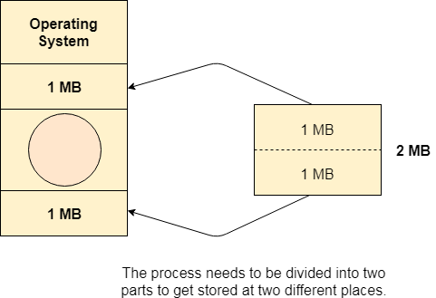

**Difference Between Paging and Segmentation**

[**Paging**](https://www.geeksforgeeks.org/paging-in-operating-system/)**:**

Paging is a method or technique which is used for non-contiguous memory allocation. It is a fixed-size partitioning theme (scheme). In paging, both main memory and secondary memory are divided into equal fixed-size partitions. The partitions of the secondary memory area unit and main memory area unit are known as pages and frames respectively.

Paging is a memory management method accustomed fetch processes from the secondary memory into the main memory in the form of pages. in paging, each process is split into parts wherever the size of every part is the same as the page size. The size of the last half could also be but the page size. The pages of the process area unit hold on within the frames of main memory relying upon their accessibility.

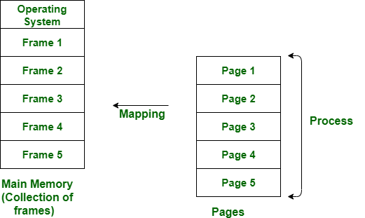

[**Segmentation**](https://www.geeksforgeeks.org/segmentation-in-operating-system/)**:**

Segmentation is another non-contiguous memory allocation scheme like paging. like paging, in segmentation, the process isn’t divided indiscriminately into mounted(fixed) size pages. It is a variable-size partitioning theme. like paging, in segmentation, secondary and main memory are not divided into partitions of equal size. The partitions of secondary memory area units are known as segments. The details concerning every segment are hold in a table known as segmentation table. Segment table contains two main data concerning segment, one is Base, which is the bottom address of the segment and another is Limit, which is the length of the segment.

In segmentation, the CPU generates a logical address that contains the Segment number and segment offset. If the segment offset is a smaller amount than the limit then the address called valid address otherwise it throws miscalculation because the address is invalid.

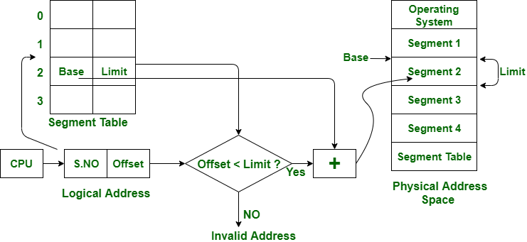

The above figure shows the translation of a logical address to a physical address.

| **S.NO** | **Paging** | **Segmentation** |
| --- | --- | --- |
| 1. | In paging, the program is divided into fixed or mounted size pages. | In segmentation, the program is divided into variable size sections. |
| 2. | For the paging operating system is accountable. | For segmentation compiler is accountable. |
| 3. | Page size is determined by hardware. | Here, the section size is given by the user. |
| 4. | It is faster in comparison to segmentation. | Segmentation is slow. |
| 5. | Paging could result in internal fragmentation. | Segmentation could result in external fragmentation. |
| 6. | In paging, the logical address is split into a page number and page offset. | Here, the logical address is split into section number and section offset. |
| 7. | Paging comprises a page table that encloses the base address of every page. | While segmentation also comprises the segment table which encloses segment number and segment offset. |
| 8. | The page table is employed to keep up the page data. | Section Table maintains the section data. |
| 9. | In paging, the operating system must maintain a free frame list. | In segmentation, the operating system maintains a list of holes in the main memory. |
| 10. | Paging is invisible to the user. | Segmentation is visible to the user. |
| 11. | In paging, the processor needs the page number, and offset to calculate the absolute address. | In segmentation, the processor uses segment number, and offset to calculate the full address. |
| 12. | It is hard to allow sharing of procedures between processes. | Facilitates sharing of procedures between the processes. |
| 13 | In paging, a programmer cannot efficiently handle data structure. | It can efficiently handle data structures. |
| 14. | This protection is hard to apply. | Easy to apply for protection in segmentation. |
| 15. | The size of the page needs always be equal to the size of frames. | There is no constraint on the size of segments. |
| 16. | A page is referred to as a physical unit of information. | A segment is referred to as a logical unit of information. |
| 17. | Paging results in a less efficient system. | Segmentation results in a more efficient system. |

# Paging in OS (Operating System)

In Operating Systems, Paging is a storage mechanism used to retrieve processes from the secondary storage into the main memory in the form of pages.

The main idea behind the paging is to divide each process in the form of pages. The main memory will also be divided in the form of frames.

One page of the process is to be stored in one of the frames of the memory. The pages can be stored at the different locations of the memory but the priority is always to find the contiguous frames or holes.

Pages of the process are brought into the main memory only when they are required otherwise they reside in the secondary storage.

ADVERTISEMENT

Different operating system defines different frame sizes. The sizes of each frame must be equal. Considering the fact that the pages are mapped to the frames in Paging, page size needs to be as same as frame size.

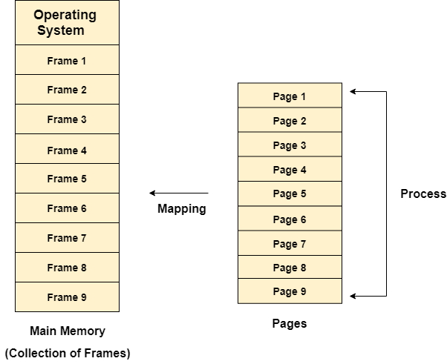

### **Example**

Let us consider the main memory size 16 Kb and Frame size is 1 KB therefore the main memory will be divided into the collection of 16 frames of 1 KB each.

There are 4 processes in the system that is P1, P2, P3 and P4 of 4 KB each. Each process is divided into pages of 1 KB each so that one page can be stored in one frame.

Initially, all the frames are empty therefore pages of the processes will get stored in the contiguous way.

Frames, pages and the mapping between the two is shown in the image below.

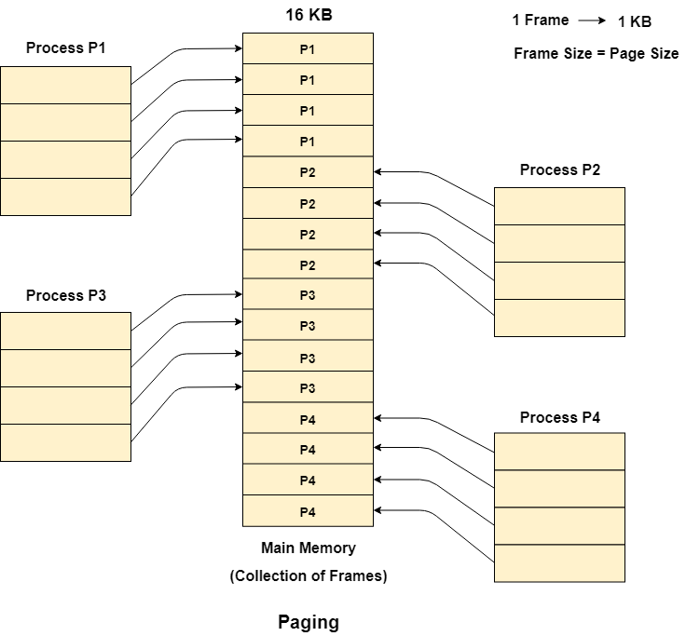

Let us consider that, P2 and P4 are moved to waiting state after some time. Now, 8 frames become empty and therefore other pages can be loaded in that empty place. The process P5 of size 8 KB (8 pages) is waiting inside the ready queue.

Given the fact that, we have 8 non contiguous frames available in the memory and paging provides the flexibility of storing the process at the different places. Therefore, we can load the pages of process P5 in the place of P2 and P4.

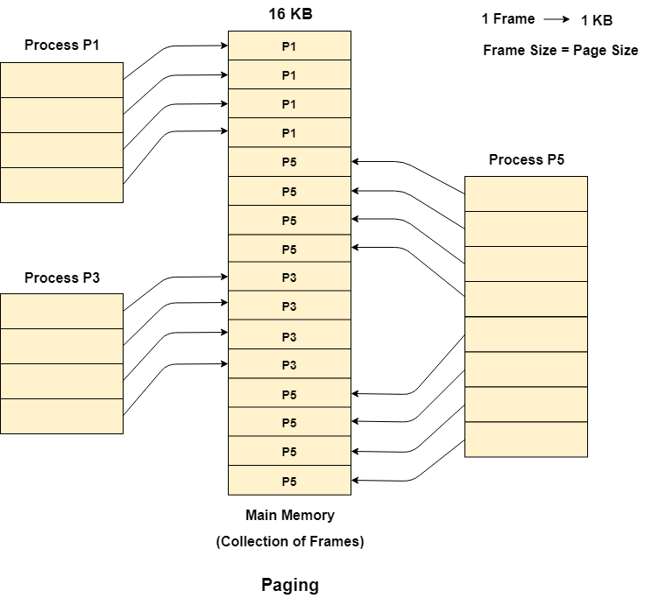

## **Memory Management Unit**

The purpose of Memory Management Unit (MMU) is to convert the logical address into the physical address. The logical address is the address generated by the CPU for every page while the physical address is the actual address of the frame where each page will be stored.

When a page is to be accessed by the CPU by using the logical address, the operating system needs to obtain the physical address to access that page physically.

The logical address has two parts.

1. Page Number
2. Offset

Memory management unit of OS needs to convert the page number to the frame number.

**Example**

Considering the above image, let's say that the CPU demands 10th word of 4th page of process P3. Since the page number 4 of process P1 gets stored at frame number 9 therefore the 10th word of 9th frame will be returned as the physical address.

# Segmentation in OS (Operating System)

In Operating Systems, Segmentation is a memory management technique in which the memory is divided into the variable size parts. Each part is known as a segment which can be allocated to a process.

The details about each segment are stored in a table called a segment table. Segment table is stored in one (or many) of the segments.

Segment table contains mainly two information about segment:

1. Base: It is the base address of the segment
2. Limit: It is the length of the segment.

## **Why Segmentation is required?**

Till now, we were using Paging as our main memory management technique. Paging is more close to the Operating system rather than the User. It divides all the processes into the form of pages regardless of the fact that a process can have some relative parts of functions which need to be loaded in the same page.

Operating system doesn't care about the User's view of the process. It may divide the same function into different pages and those pages may or may not be loaded at the same time into the memory. It decreases the efficiency of the system.

It is better to have segmentation which divides the process into the segments. Each segment contains the same type of functions such as the main function can be included in one segment and the library functions can be included in the other segment.

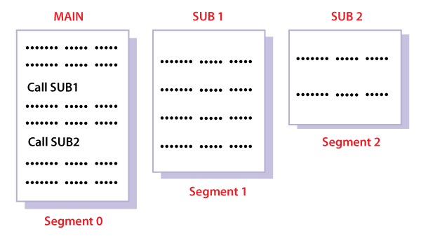

## **Translation of Logical address into physical address by segment table**

CPU generates a logical address which contains two parts:

1. Segment Number
2. Offset

**For Example:**

Suppose a 16 bit address is used with 4 bits for the segment number and 12 bits for the segment offset so the maximum segment size is 4096 and the maximum number of segments that can be refereed is 16.

When a program is loaded into memory, the segmentation system tries to locate space that is large enough to hold the first segment of the process, space information is obtained from the free list maintained by memory manager. Then it tries to locate space for other segments. Once adequate space is located for all the segments, it loads them into their respective areas.

The operating system also generates a segment map table for each program.

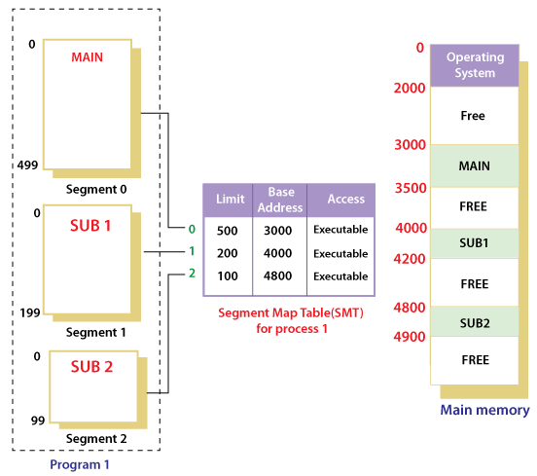

With the help of segment map tables and hardware assistance, the operating system can easily translate a logical address into physical address on execution of a program.

The **Segment number** is mapped to the segment table. The limit of the respective segment is compared with the offset. If the offset is less than the limit then the address is valid otherwise it throws an error as the address is invalid.

In the case of valid addresses, the base address of the segment is added to the offset to get the physical address of the actual word in the main memory.

The above figure shows how address translation is done in case of segmentation.

## **Advantages of Segmentation**

1. No internal fragmentation
2. Average Segment Size is larger than the actual page size.
3. Less overhead
4. It is easier to relocate segments than entire address space.
5. The segment table is of lesser size as compared to the page table in paging.

## **Disadvantages**

1. It can have external fragmentation.
2. it is difficult to allocate contiguous memory to variable sized partition.
3. Costly memory management algorithms.